**Reduced Cost Construction of Jacobian Matrices for High-Resolution Inverse Modeling: An Application to Optimizing North American Methane Sources from GOSAT Satellite Data**

**Authors**

Hannah Nesser1, Daniel J. Jacob1, Joannes D. Maasakkers2, Melissa P. Sulprizio1, Yuzhong Zhang1, Tia Scarpelli1

**Affiliations**

**1** Harvard University, Cambridge, Massachusetts, USA.

2 SRON Netherlands Institute for Space Research, Utrecht, the Netherlands.

**Abstract**

Global high-resolution observations of atmospheric trace gas concentrations from satellites can greatly improve our understanding of surface emissions through inverse analyses. For example, the new Tropospheric Monitoring Instrument (TROPOMI) retrieves daily global observations of atmospheric methane concentrations at 7x7 km2 pixel resolution. Variational inverse methods can optimize surface emissions globally at this resolution but do not readily provide error characterization, including information content, for the posterior solution. In fact, the information content of the satellite data may be considerably lower than the data density would suggest because of limited retrieval success rate, instrument noise, and error correlations that propagate through the inversion. This could lead to smoothing errors in variational methods. An analytic inverse solution provides closed-form characterization of the posterior error statistics and information content but requires the construction of the Jacobian matrix relating emissions to atmospheric concentrations. Building the Jacobian matrix is computationally expensive at fine resolution because it involves perturbing each emission element, typically individual grid cells, in the atmospheric transport model. We propose a method to greatly decrease the computational cost of analytic inversions by constructing the Jacobian matrix using only the emission elements with sufficient information content from the observations. Starting from an initial estimate of the Jacobian matrix that assumes simple transport, we iteratively apply perturbations to the leading patterns of information content rather than to the individual model grid cells. The resulting matrix optimizes emissions only in areas spanned by these leading patterns. We demonstrate the method in an analytic Bayesian inversion of GOSAT data over North America in July 2009. We confirm that the estimated Jacobian matrix produces posterior emission estimates and error covariances that are similar to an inversion conducted with the Jacobian matrix for the original model grid. Our method enables computationally efficient, high-resolution analytic inversions of high-density satellite data.

**Section 1: Introduction**

Satellite observations of atmospheric composition provide an increasingly powerful resource to improve our knowledge of emissions. The satellite data have typically high coverage and density but are subject to large errors, both in the measurement retrieval and in the model interpretation of the data to infer emissions. One would like to exploit the satellite data to quantify emissions at suitably high resolution but with reliable error characterization and within in a computationally tractable framework. This paper aims to develop such a capability.

The general inverse approach for inferring emissions from observations of atmospheric composition is to fit the data to a chemical transport model (CTM) that simulates atmospheric concentrations on the basis of emissions. The CTM represents the forward model for the inverse problem. The inversion is generally done by Bayesian optimization, with minimization of a cost function that takes into account errors in the measurements and in the CTM, and regularizes the solution with prior information on emissions. The solution to the minimization problem is usually obtained numerically (variational method), often using the adjoint of the CTM for efficient computation of the cost function gradient (Henze ref). But characterizing the error on the solution is then problematic. One can estimate the error through an ensemble or by perturbations about the solution (ref) but these methods are computationally expensive.

In the special but frequent case when the relationship between emissions and atmospheric concentrations is linear and the errors can be assumed normal, an analytical solution to the Bayesian optimization problem can be achieved including closed-form characterization of the errors and information content of the solution (Brasseur and Jacob 2017). This analytical solution can be extended to non-linear problems and log-normal errors with an iterative approach (Rodgers, 2000; Maasakkers et al., 2019). The computational cost of the analytical approach is mainly determined by the required construction of the (*m*×*n*) Jacobian matrix **K**  = ∂**y**/∂**x** which describes the model sensitivity of the observed concentration vector **y** (dimension *m*) to the emission state vector **x** (dimension *n*) being optimized. . Once the Jacobian matrix has been constructed, it is possible to explore at essentially no added computational cost the sensitivity of the solution to different specification of errors, different prior assumptions, adding/subtracting observations, condensing the state vector, etc. This is a major but often not recognized advantage of the analytical method, in addition to the ability to formally characterize error on the solution and information content.

Construction of the Jacobian matrix is done column by column, by conducting *n* CTM simulations with perturbed values of each of state vector elements *x­i,* and collecting the resulting matrix columns ∂**y**/∂*xi*. The individual simulations are independent so that the construction can be done efficiently on massively parallel computing clusters. Nevertheless, the computational cost can limit the size of the state vector **x**, and this can be a roadblock when attempting to exploit dense satellite observations.

An illustration of this challenge is the use of methane concentrations observed by satellites to infer the emissions of methane, a major greenhouse gas. The main satellite instrument to observe methane so far has been GOSAT, launched in 2009, which measures atmospheric methane columns with 10-km diameter pixels about 250 km apart latitudinally and longitudinally. The information from GOSAT is sufficiently sparse that it can be accommodated in an analytical inversion with ~1000 state vector elements on an emission grid, for which construction of the Jacobian matrix is computationally practical ((Maasakkers et al. 2019). But the situation is changing with the October 2017 launch of the Tropospheric Ozone Monitoring Instrument (TROPOMI), whichnow provides daily global retrievals of atmospheric methane columns at 7 x 7 km2 nadir pixel resolution, increasing coverage by orders of magnitude compared to GOSAT. A complication is that TROPOMI retrievals have only a ~3% success rate limited by clouds, high aerosol loadings, and variable surface albedo and topography. As a result, TROPOMI produces very inhomogeneous methane observations with spatially variable information content. Analytical solution to the inverse problem can be tailored to this information content but computational tractability is a concern.

Several methods have been developed to tailor the resolution of inversions to the information content of the observing system and effectively decrease in this manner the computational cost.Starting from a native high-resolution grid of emissions (large *n*), these methods reduce either the dimension or the rank of the problem to optimally fit the information content of the observations or the available computational resources. Bocquet et al. (2011) defined a method to find the optimal multiscale grid for the inversion state vector, starting from thenative high-resolution grid. However, optimizing across all allowed grids mitigates the computational benefit. Turner and Jacob (2015) reduced the dimension of the native grid using a *k*-member Gaussian mixture model (*k* < *n*) on which the high-resolution grid cells were projected using similarity criteria., but selection of these criteria was subjective criteria. Reduced rank approaches defined first by Spantini et al. (2015) and elaborated on by Bousserez and Henze (2018) took advantage of the variability of information content in an inverse system and solved the inversion only in the directions with highest information content. The resulting low-rank approximations for the posterior solution decrease the computational cost of inverting dense *n* x *n* matrices but not the cost of constructing the Jacobian. Bousserez and Henze (2018) define also a random matrix approach for constructing the rank-reducing projection. This approach employs both the forward model and the adjoint, increasing the computational cost and requiring continued development of the adjoint.

Here we solve the following problem. Given a high-resolution grid of dimension *n* for the emission state vector, how can we construct the (*n* × *m*) Jacobian matrix using only *k* < *n* forward model simulations to achieve a rank *k* approximation that prioritizes the information content of the observing system? The idea is to enable analytical inversion for high-resolution satellite data sets with limited information content, such as TROPOMI methane, not pre-judging that information content and hence retaining the native high-resolution emission grid. We define an a posteriori filter that sets the Jacobian to zero in areas without sufficient information content. The resulting posterior solution optimizes emissions only in those areas with high information content and defaults to the prior estimate elsewhere. Starting from an initial estimate of the Jacobian matrix, we populate the matrix successively along the dominant patterns of information content in the system, with a user-selected cut-off at rank *k* that represents a trade-off between computational tractability and information content. We apply the method to a 1-month inversion of satellite data as an illustrative test.

[INSERT PARAGRAPH THAT DESCRIBES TWO APPROACHES]

**Section 2: Methods**

Section 2.1: Analytic solution to the inversion solution

TBayes’ theorem assuming normal errors allows the explicit formulation of a cost function **J**(**x**) that, when minimized over the dimension of the state vector **x**, provides an optimal posterior estimate $\hat{x}$ for that state vector given the observations **y** with observational error covariance matrix **SO** and a prior estimate **xA** with error covariance matrix **SA**:

f the forward model is linear so that **F**(**x**) = **Kx** + **c**, where **c** is a constant, an analytic solution to the cost function minimum exists that yields not only the posterior estimate $\hat{x}$ but also the posterior error covariance matrix $\hat{S}$ for $\hat{ x}$**:** :



Comparison of **Shat** and **SA** defines the information content of the observing system, quantified by the averaging kernel matrix **A** = ∂**xhat**/∂**x** = **I** – **ShatSA-1** that represents the sensitivity of the solution **xhat** to the true state **x**:



The trace of **A** estimates the number of pieces of information that can be obtained from the observing system and is called the Degrees Of Freedom for Signal (DOFS).

In an analytic inversion of satellite observations, where the number of observations is much larger than the number of state vector elements, *m* >> *n*, the computational cost is determined by the cost of constructing the Jacobian matrix **K**. The Jacobian is typically constructed column-wise by computing the model response to a perturbation of each state variable, requiring *n* + 1 forward model simulations. With a CTM as forward model and large value for *n*, the computation is expensive. However, the DOFS may be much less than *n*. In that case, the computational cost of constructing the Jacobian matrix can be reduced by (1) decreasing the dimension *n* **x** by aggregating or ignoring the original state vector elements or (2) retaining the original dimension but decreasing the number of model simulations, yielding a low-rank approximation of the Jacobian. Optimal reductions in both dimension and rank will maximize the information content of the resulting inversion. In what follows, we consider the case in which the state vector elements are surface emissions, discretized over a grid. The results can be generalized to temporal as well as spatial state variables.

Section 2.2: Optimal Rank and Dimension Reductions

[INSERT KITCHEN SINK RECIPE]

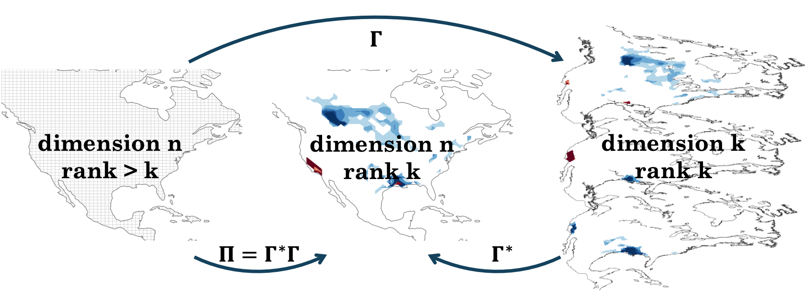

Figure 1

Figure 1 shows the relationship between dimension and rank reductions. The left panel represents the original *n*-dimensional state space. A linear transformation $Γ∈R^{n ×k}$ reduces the dimension of the state space from *n* to *k*. This transformation may reduce dimension discretely, as in the case of grid cell aggregation, or non-discretely, as depicted in the right panel. A second linear transformation $Γ^{*}∈R^{k ×n}$ can extend the dimension of the state space from *k* back to the original *n*. The resulting space, depicted in the middle panel, is a low-rank approximation of the original state space. The projection $Π=Γ^{*}Γ$ transforms the original state space to the low-rank subspace. An inverse system, including the Jacobian, can be constructed and solved in any of the three spaces. As the dimension or rank of the subspace approaches the original dimension, i.e. as $k→n$, the inverse solution converges to the true solution.

For a given dimension-reducing transformation $Γ$, the optimal dimension-restoring transformation $Γ^{*}$ maximizes the probability of the full dimension state vector **x** given the reduced-dimension state vector $Γx$. Bousserez and Henze (2018) show for any given $Γ$ the resulting optimal rank *k* projection $Π$ can be written in the form $Π=S_{A}^{1/2}UU^{T}S_{A}^{{-1}/2}$ where $U=S_{A}^{1/2}Γ{\left(ΓS_{A}Γ^{T}\right)}^{-1/2}$. This projection can be understood as a dimension-reducing transformation $U^{T}S_{A}^{{-1}/2}$ followed by a dimension-restoring transformation $S_{A}^{1/2}U$. Within this class of projections, the projection that maximizes the information content of the resulting reduced-rank subspace will maximize the degrees of freedom for signal given by the trace of the reduced-rank averaging kernel matrix $A_{Π}$. [Insert sentence about how we need to find the best value for U.] Bousserez and Henze (2018) show that for a projection of this form, $Tr\left(A_{Π}\right)=Tr\left(U^{T}S_{A}^{-1/2}AS_{A}^{1/2}U\right)$. [or here.] Define

$$\begin{aligned}Q= S_{A}^{-1/2}AS_{A}^{1/2}=WΣW^{T}\#\left(5\right)\end{aligned}$$

where the columns of **W** are the eigenvectors of $Q$ and the diagonal elements of $Σ$ are the corresponding eigenvalues of $Q$ ranked in descending order. Because $Q$ is a symmetric semi-positive definite matrix, the eigenvectors form an orthonormal basis for the space spanned by $Q$. As a result, $W^{T}W=WW^{T}=I$ and $Tr\left(A_{Π}\right)$ is maximized when $U=W_{k}$ where $W_{k}$ is the matrix of the first *k* columns of **W**, with *k* corresponding to the rank of the projected subspace. The projection that maximizes the information content of the resulting subspace is then

$$\begin{aligned}Π=S_{A}^{1/2}W_{k}W_{k}^{T}S_{A}^{{-1}/2}.\#\left(6\right)\end{aligned}$$

This projection applies a dimension-reducing transformation $R=W_{k}^{T}S_{A}^{{-1}/2}$ followed by a dimension-restoring transformation $P=S_{A}^{1/2}W_{k}$. The columns of **P** and $R^{T}$ give the *k* leading right and left eigenvectors, respectively, of the averaging kernel matrix **A** (Rodgers 2000). The eigenvalues of **Q** are also the eigenvalues of the averaging kernel matrix. Bousserez and Henze (2018) show that the sum of the first *k* largest eigenvalues gives the DOFS of the rank *k* subspace given by equation (6). In any inverse system, then, the fraction of information content explained by the first *k* right eigenvectors of **A** is the sum of the first *k* largest eigenvalues divided by the total DOFS. Moreover, the diagonal of

$$\begin{aligned}Λ=Σ{\left(I-Σ\right)}^{-1}\#\left(7\right)\end{aligned}$$

gives the singular values of the pre-whitened Jacobian matrix $\tilde{K}=S_{O}^{-1/2}KS_{A}^{1/2}$, which give the signal-to-noise ratio of each eigenvector (Rodgers 2000). The rank *k* can then be chosen so that the *k* leading eigenvectors explain most of the information content in the inverse system or so that all eigenvectors have a sufficiently large signal-to-noise ratio.

We use the rank *k* projection as defined in equation (6) with *k* selected according to the above criteria to define the dimension *n* rank *k* subspace within which we construct our inverse problem. We decrease the computational cost of constructing the Jacobian matrix **K** by (1) building the matrix on a multiscale grid on the basis of the reduced-rank information content and (2) generating a low-rank approximation by constructing the Jacobian matrix in the directions of dominant information content, given by the eigenvectors spanning the space. Both methods rely on the projection $Π$, which is itself a function of the Jacobian. We therefore propose a two-step update method to construct the Jacobian matrix. The full dimension Jacobian matrix is initialized at low computational cost using prior emissions information, generating $K^{(0)}$. We generate the corresponding averaging kernel matrix and select the *k* eigenvectors that explain most of the information content in the initial system. We then construct the Jacobian matrix within the resulting rank *k* subspace on either a multiscale grid or a reduced-rank basis. Because the updated Jacobian matrix $K^{(1)}$ contains contributions from the prior emissions estimate, the observations, and the forward model, the leading eigenvectors of its averaging kernel matrix more accurately span the information content of the inverse system. We use these improved eigenvectors to calculate the final Jacobian matrix update. In what follows we describe the initialization of the Jacobian matrix (Section 2.1), the construction of the multiscale grid Jacobian matrix (Section 2.2), and the construction of the reduced-rank Jacobian matrix (Section 2.3).

**Section 2.1: Initializing the Jacobian Matrix**

A simple, computationally-inexpensive mass-balance approximation relates emission enhancements to local concentration enhancements (Jacob et al. 2016) and can be used as an initial estimate of the Jacobian matrix $K^{(0)}$. Given a perturbation to the prior emissions in the *i*th grid cell, $Δx_{i}$, the change in *j*th observation $Δy_{j}$ is estimated as

$$\begin{aligned}Δy_{j}=α_{ij}\frac{M_{air}}{M_{X}}\frac{g}{UWP} Δx_{i}\#\left(8\right)\end{aligned}$$

where $α_{ij}$ is a factor that decreases with the distance of the *j*th observation from the *i*th grid cell, *M*air and *M*x are the molecular weights of dry air and the optimized species, respectively, *g* is gravity, *U* is the wind speed, *W* is the distance the wind travels across the grid box, and *P* is the surface pressure (Jacob et al. 2016). The Jacobian is then constructed column-wise with the *i*th column given by $Δy/Δx_{i}$.

**Section 2.2: Constructing the Jacobian Matrix on a Multiscale Grid**

Reducing the dimension of the state vector by aggregating grid cells lowers the computational cost of inversions with large state vectors by decreasing the number of model runs needed to construct the Jacobian matrix (Bocquet and Wu 2011; Turner and Jacob 2015). A multiscale grid that preserves resolution where information content is high and goes to coarser resolution elsewhere will allow solution of the inverse problem in areas with sufficient information at minimal computational cost. In an inverse system with a known Jacobian matrix **K**, a multiscale grid can be constructed on the basis of the eigenvectors of the averaging kernel matrix **A** that best explain the system’s information content, given by the columns of the dimension-restoring transformation **P**. The rows of **P** describe the contribution of each grid cell to each eigenvector. Then, the row-wise magnitude of **P**, as measured by the L2 norm and described by the vector $s$, is a measure of each grid cell’s significance in the low-rank information content. Where $s$ is largest, we preserve the original state vector resolution. Elsewhere, we consolidate grid cells to achieve the desired dimension. K-means clustering aggregates together spatially proximate grid cells that are likely to yield similar model responses but neglects the variation in emissions magnitudes or profiles in different grid cells. An algorithm that considers the similarity of emissions, such as the Gaussian mixture model implemented by Turner and Jacob (2015), could also be used. The reduced-dimension Jacobian matrix $K_{mg}$ can then be constructed on the multiscale grid by calculating the model response to perturbations of each grid element.

Without a fully characterized Jacobian matrix, the multiscale grid can be constructed in a two-step update that iteratively improves an initial estimate of the inverse system’s information content. We use the initial estimate of the Jacobian matrix $K^{(0)}$ to calculate an averaging kernel matrix $A^{(0)}$ and its eigenvectors $P^{(0)}$. We select the $k^{(0)}$ eigenvectors that have a signal-to-noise ratio greater than or equal to one and generate the significance vector $s^{(0)}$. We construct an initial multiscale grid and the associated reduced-dimension Jacobian $K_{mg}^{\left(1\right)}$, introducing information content from the forward model to the inverse system. We regrid $K_{mg}^{\left(1\right)}$ to the original grid with weights given by the prior emissions estimate and repeat the process of generating a multiscale grid. On the second update, we use the $k^{(1)}$ eigenvectors that span most of the information content from the initial estimate. While the eigenvalues of $A^{(0)}$ underestimate the DOFS relative to the “true” inverse system, incorporating information content from the forward model will not substantially change the rate at which the eigenvalues decrease. Then, we generate the updated significance vector $s^{(1)}$. To avoid superfluous model runs, the multiscale grid is adjusted only where the relative difference between $s^{(0)}$ and $s^{(1)}$ is sufficiently large. We then construct the reduced-dimension Jacobian $K_{mg}^{\left(2\right)}$ on the updated multiscale grid.

The information content associated with both $K_{mg}^{\left(1\right)}$ and $K_{mg}^{\left(2\right)}$ includes contributions from prior emissions estimates, the observations, and the forward model. As a result, the leading directions of information content associated with the $K_{mg}^{\left(2\right)}$ are largely the same as those associated with $K_{mg}^{\left(1\right)}$. Further iterations would improve the characterization of the patterns of low information content relative to the true patterns, but these eigenvectors would not change the multiscale grid. We therefore take $K_{mg}^{\left(2\right)}$ as our Jacobian matrix. The analytic inversion can the be solved exactly on the multiscale grid. In order to interpret the inverse results at the original state vector resolution, additional information must be introduced to allocate the posterior solution to the original grid. The weights could, for example, be given by the prior emissions estimate. However, this introduces additional error. To solve the inversion at the original state vector resolution, it is necessary to reduce the rank and not the dimension of the inverse system.

**Section 2.3: Constructing a Reduced-Rank Approximation of the Jacobian Matrix**

A reduced-rank Jacobian matrix characterizes the linear relationship between emissions and observations in the directions that best represent the information content of the inverse system. To understand what a reduced-rank Jacobian matrix represents, consider first an inverse system with a known Jacobian matrix **K** and the corresponding averaging kernel matrix **A**. We showed earlier that the patterns of information content, given by the eigenvectors of **A** or, equivalently, by the columns of the dimension-restoring transformation **P**,form an orthogonal basis for the information content of the inverse system. The eigenvectors with the largest corresponding eigenvalues explain the largest fractions of the variance in the information content. For any *k*, the *k* leading eigenvectors span a rank *k*, dimension *n* subspace of the original information content space. A Jacobian matrix can be constructed within this space by calculating the model response to perturbations given by these eigenvectors. The response of a forward model F to the *j*th eigenvector $p_{j}∈R^{n}$, given by the *j*th column of $P$, is

$$\begin{aligned}y_{j}=\frac{F\left(x_{A}+αp_{j}\right)-F\left(x_{A}\right)}{α}\#\left(9\right)\end{aligned}$$

where $α$ is a scaling factor applied to ensure numerical stability. The model responses $y_{j}, j∈\left\{1, …, k\right\}$ form the columns of the matrix $K_{ω}∈R^{m × k}$, which is the Jacobian for an inverse system with a reduced-dimension state space spanned by the first *k* eigenvectors of the information content. This reduced-dimension Jacobian must be transformed to the original state dimension for use in analytic inversions. If the forward model is linear, F can be written as $K_{true}$ and $K_{ω}$ as $K_{ω}=K_{true}P$. Bousserez et al. (2018) show that the reduced-rank Jacobian $K_{Π}$ is given by $K_{Π}=K_{true}Π=K_{true}PR.$ Then, the reduced-rank Jacobian can be calculated from the reduced-dimension Jacobian by $K_{Π}= K_{ω}R$. The resulting Jacobian has dimension $m×n$ and rank $k$.

In an inverse system without a known Jacobian matrix, the reduced-rank Jacobian matrix approximation can be constructed in a two-step update that iteratively improves the patterns of information content used as perturbations. We use the initial estimate of the Jacobian matrix $K^{(0)}$ to calculate an averaging kernel matrix $A^{(0)}$ and its eigenvectors $P^{(0)}$. We select the $k^{(0)}$ eigenvectors that have a signal-to-noise ratio greater than or equal to one and calculate the model response to each of the eigenvectors using equation (9). We transform the resulting reduced-dimension Jacobian $K_{ω}^{(1)}$ to the full-dimension state space with $K_{Π}^{(1)}= K_{ω}^{(1)}R^{(0)}$, generating a rank $k^{(0)}$ approximation of the Jacobian on the basis of the initial eigenvectors of information content.

The reduced-rank Jacobian matrix approximation $K_{Π}^{(1)}$ introduces information from the forward model to the inverse system. We calculate the associated averaging kernel matrix $A^{(1)}$ and its eigenvectors $P^{(1)}$. We use the $k^{(1)}$ eigenvectors that span most of the information content from the initial estimate, as defined by the eigenvalues of $A^{(0)}$. We cannot use the updated information content to determine *k* because we reduced the rank of the inverse system, so most of the information content described by $A^{(1)}$ is contained in the first $k^{(0)}$ eigenvectors. However, $k^{(0)}$ underestimates the true rank of the system because information is contained in eigenvectors even when their signal-to-noise ratio is less than one. In contrast, the eigenvalues of $A^{(0)}$ may underestimate the DOFS relative to the “true” inverse system but are likely to accurately capture the spectrum of information content; information content from the forward model is unlikely to change the rate at which information content decreases with increasing eigenvector index. Then, on the basis of the first $k^{(1)}$ eigenvectors of information content, we construct an updated reduced-rank Jacobian matrix approximation $K_{Π}^{(2)}$ as above.

The resulting Jacobian matrix $K_{Π}^{(2)}$ is a rank $k^{(2)}$ approximation of the linear forward model. It accurately quantifies the forward model where the inverse system has high information content as and loses accuracy in areas with lower information content. The resulting posterior emissions and error are similarly biased. In areas with lower information content, the posterior emissions estimate tends toward the prior emissions estimate. To eliminate outliers and reduce error in the inverse solution, we set the posterior emissions estimate to the prior value in grid cells where the trace of the averaging kernel matrix $A^{(2)}$ is small. We discuss the selection of the threshold for information content in Section 3, where we demonstrate the reduced-dimension and reduced-rank approaches as they apply to an inversion of atmospheric methane columns observed by the GOSAT satellite over North America in July 2009.

**Section 3: Results and Discussion**

We demonstrate both the reduced-dimension and reduced-rank Jacobian matric construction approaches in an analytic Bayesian inversion of atmospheric methane columns observed by the GOSAT satellite over North America in July 2009. We construct a true Jacobian matrix at 1º x 1.25º resolution, a reduced-dimension Jacobian matrix with ~300 state vector elements, and a rank 200 Jacobian matrix. We also construct a reduced-dimension Jacobian matrix following the Gaussian mixture model (GMM) method described by Turner and Jacob (2015). We use those Jacobian matrices within the inverse framework described by Maasakkers et al. (2019), adapted from the global system to the North American domain. We solve for posterior scaling factors and compare results. [Insert summary of results.]

In all inversions, we use the nested North American GEOS-Chem CTM version 12.4.0 as forward model to simulate atmospheric methane column concentrations at 0.5º x 0.625º resolution. The model is driven with MERRA-2 meteorological fields (Bosilovich et al., 2016) from the NASA Global Modeling and Assimilation Office (GMAO). We use boundary conditions and initial conditions [check this] from a global GEOS-Chem 4º x 5º simulation for July 2009 driven by prior emissions with posterior scaling factors applied as described by Maasakkers et al. (2019). All inversions also use the prior emissions, prior error covariances, observations, and observational error covariances as described by Maasakkers et al. (2019). In particular, we use the University of Leicester version 7 CO2 proxy retrieval over land (Parker et al. 2011, 2015) for July 2009, excluding glint data and observations north of 60ºN. Figure 1 shows the GOSAT data used by all inversions.

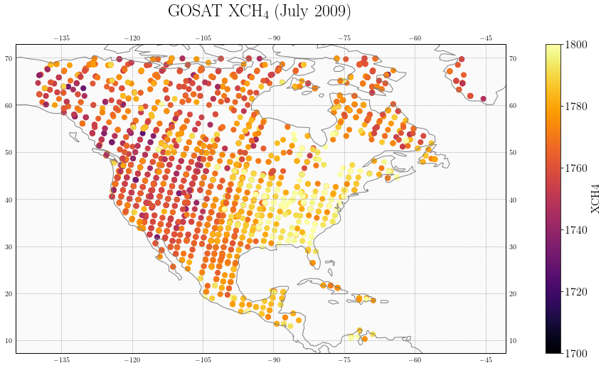

Figure 1: GOSAT atmospheric methane column retrievals for July 2009

Figure 2 shows the information content of the true system, as given by the diagonal elements of the averaging kernel. Grid boxes with large (close to one) values have more information content, or a stronger ability to constrain emissions. Grid boxes with small (close to zero) values have less ability to constrain emissions. The information content displays significant spatial variability. Notably, all grid boxes have relatively low averaging kernel values because of the limited number of observations incorporated into the inversion. Introducing more observations may change the distribution of the information content but the spatial variability would likely be preserved. This spatial variability justifies the reduced-dimension and low-rank Jacobian approaches.

The wind speed, length scale, and pressure can either be assumed constant or generated by a single model run.??

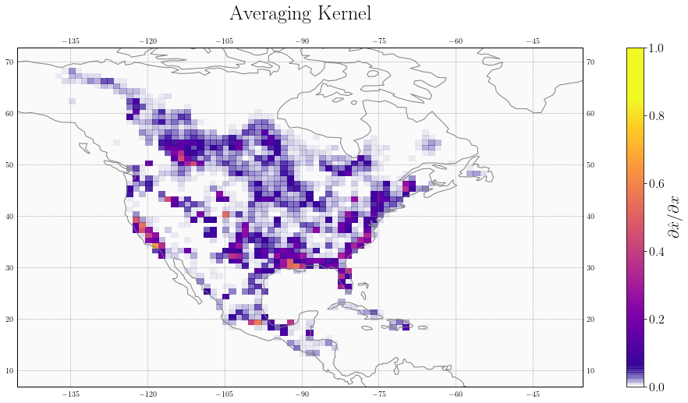

Figure 2: Information content of the true inverse system, as given by the diagonal elements of the averaging kernels. The inversion can better constrain emissions in grid boxes with large (closer to one) averaging kernel values.

We use a 1º x 1.25º grid as the base resolution for all Jacobians. The true Jacobian is constructed by perturbing aggregated 0.5º x 0.625º grid boxes, requiring 2,098 model runs. The initial estimate for the reduced-dimension and low-rank Jacobians is constructed following the mass balance approach described in Section 2. Figure 3 shows the initial estimate Jacobian elements plotted against the true Jacobian elements. While the elements of the initial estimate are of the same order of magnitude as the true Jacobian, significant scatter exists in the values. However, the patterns of information content, given by the eigenvectors of $Q^{(0)}$, are broadly consistent with the true patterns of information content. As illustration, the top row of figure 4 shows the first four patterns of information content for the true Jacobian, while the second row shows those patterns for the initial estimate. The third row shows the eigenvalue spectrum for the true and initial Jacobians, illustrating the similarity in the information content explained by each of the eigenvectors for both the true and initial inverse systems.

To demonstrate the efficacy of the reduced-dimension and low-rank Jacobian methods proposed, we construct both Jacobians with the goal of reducing the number of model runs by an order of magnitude, from ~2,000 to ~200-300. It is worth noting that increasing the number of model runs, particularly in the second iteration of both methods, will always increase the accuracy of the Jacobian relative to the true Jacobian. Generally, then, the number of model runs should be set by computational limits. We consider first the reduced-dimension and then the low-rank Jacobians.

[Paragraph about reduced-dimension Jacobian

Note: I don’t currently have this paragraph completed. I need to think of a way to evaluate the accuracy of the reduced-dimension Jacobian. While the posterior solution is exact on the multi-scale grid, it loses significant accuracy when regridded to the original resolution.



Figure 3: Mass-balance estimated Jacobian plotted element-wise against the true Jacobian. [Note: I’ll get rid of the text in the upper left in the next version of this plot.]

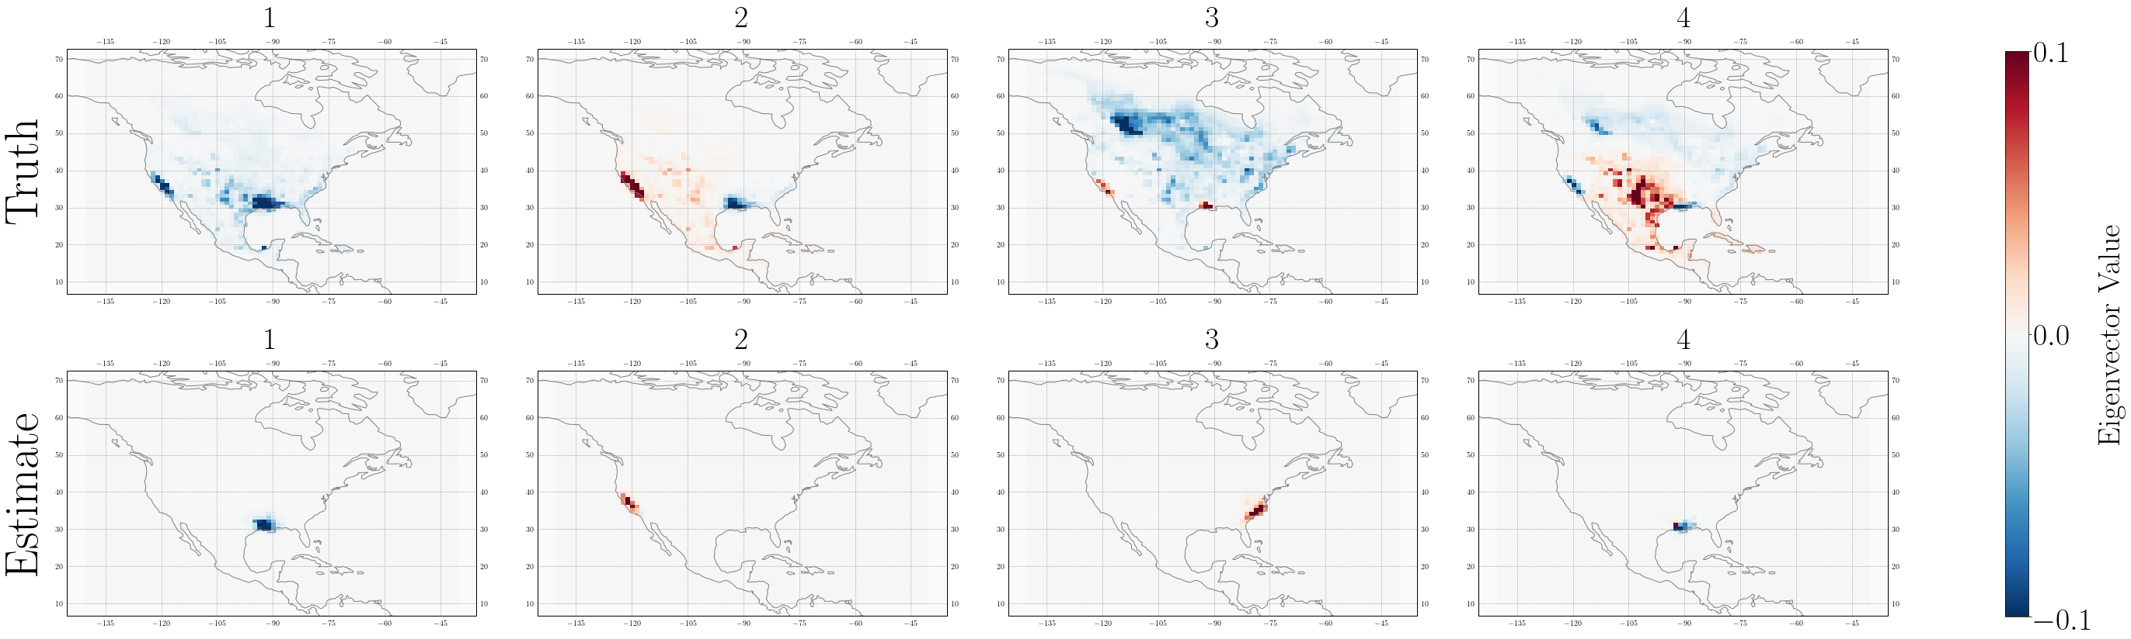

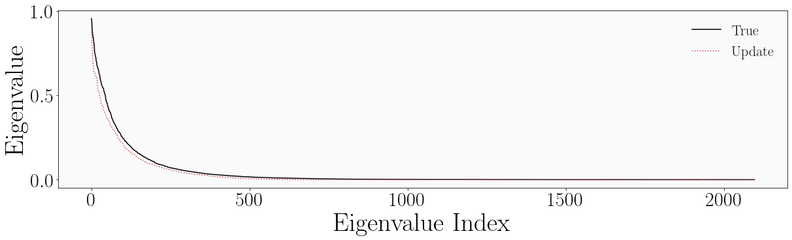

Figure 4: Eigenvectors and eigenvalues of the mass-balance estimated Jacobian and true Jacobian. The top row shows the first four eigenvectors of $Q^{true}$ and the second row the first four eigenvectors of $Q^{(0)}$. While significant differences exist in the exact patterns, the estimated Jacobian generates patterns of information content that capture the broad regions contained in the true patterns. These similarities persist beyond the first four eigenvectors. The bottom row shows the spectra of the eigenvalues associated with the true Jacobian (black) and the estimated Jacobian (red dashes) [Note: I’ll change the label “Update” to “Initial Estimate.”] The two spectra are similar, demonstrating that similar fractions of information content are captured by each eigenvector. [Note: I will also make the fonts a consistent size.]

Paragraph about reduced-dimension Jacobian, cont.

Figure 5: Plot showing the delineations of the final multi-scale grid

Figure 6: Plot showing posterior solution on multi-scale grid [left] and the posterior solution – true solution on multi-scale grid [center] and the posterior solution vs. the true solution [right]

? Figure 7: Plot showing scatter of Jacobian, posterior mean, and posterior variance?]

The low-rank Jacobian is constructed in two iterations. Because the averaging kernel corresponding to the mass balance Jacobian lacks contributions from the model and observations, the tailing patterns of information content may not span the same information content space as the “true” tailing patterns. We therefore update the initial Jacobian by perturbing the patterns that correspond to 80% of the information content, requiring 102 model runs. Figure 7 shows the first four eigenvectors and eigenvalue spectrum for the updated and true Jacobian, following the same format as figure 4. The eigenvectors associated with the updated Jacobian better capture the true patterns of information content for approximately the first 100 eigenvectors (the first four are shown here as a demonstration). The eigenvalue spectrum exhibits a discontinuity near index 100, consistent with a rank 100 approximation. We update the second Jacobian by perturbing the first 204 patterns to ensure that we capture the additional patterns of information content introduced by the first update. Visual inspection shows that the first several hundred patterns of information content associated with the first and second updates are similar, demonstrating convergence. [Delete previous sentence and insert improved convergence statement: compare averaging kernels of previous and current update.]

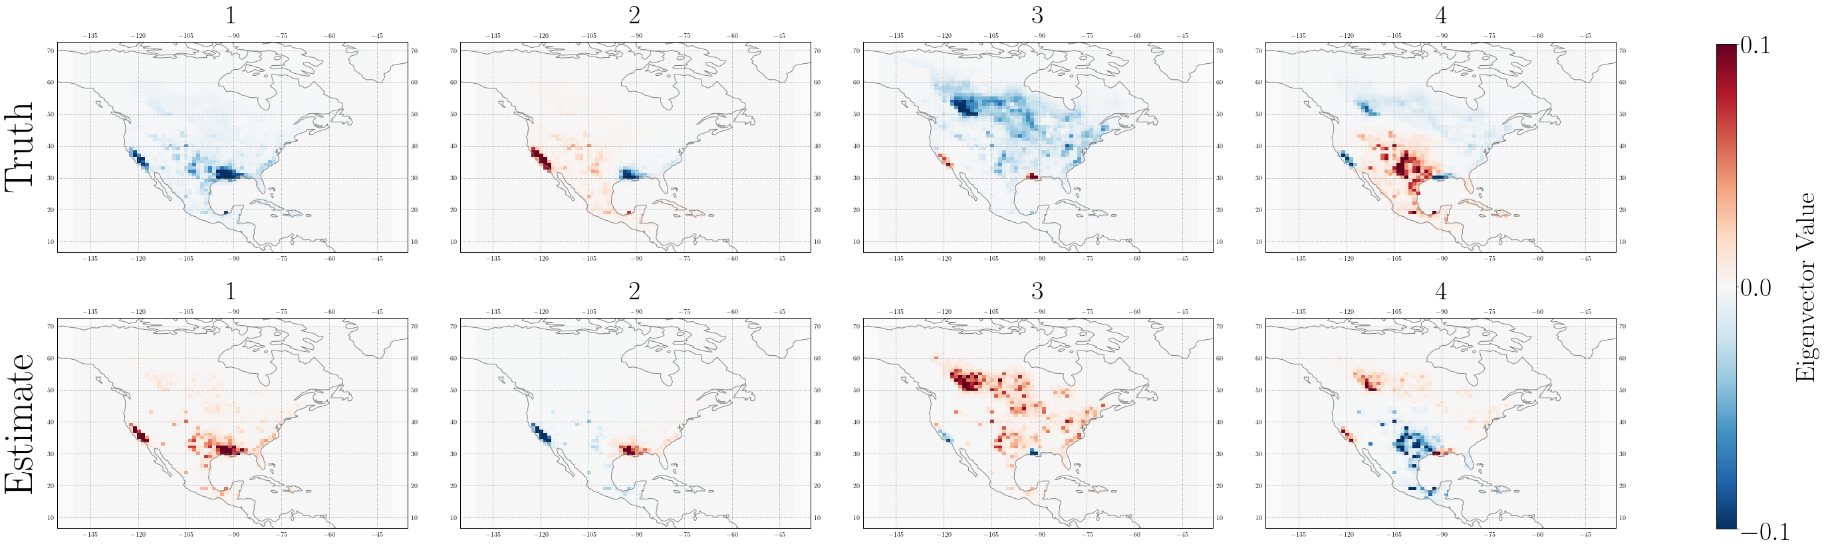

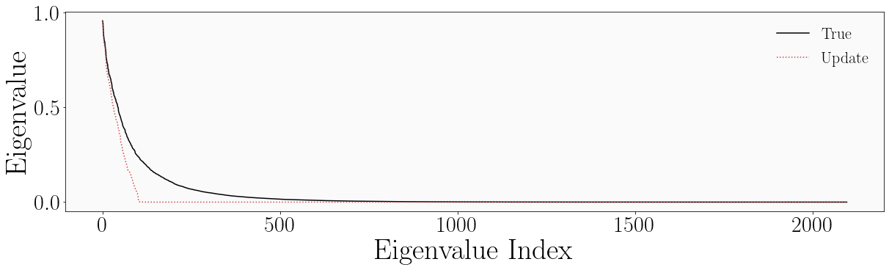

Figure 7: Eigenvectors and eigenvalues of the first update Jacobian and true Jacobian. The eigenvectors associated with the first update Jacobian better capture the patterns given by the true eigenvectors. Variations in sign are unimportant and variations in order are negligible. The eigenvalue spectrum corresponding to the first update Jacobian exhibits a discontinuity around index 100, consistent with its rank.

The first row of figure 8 shows the resulting low-rank Jacobian and the corresponding posterior mean and posterior variance plotted against the true Jacobian, posterior mean, and posterior variance, from left to right. The resulting posterior mean, shown in the center panel, corresponds well with the true posterior mean, with an r2 of 0.63. The fit is negatively affected by the cluster of values where the posterior mean associated with the low-rank Jacobian is equal to one. These values occur in grid boxes where the Jacobian does not optimize the posterior and instead maintains the prior value. These non-optimized grid boxes correspond to those grid boxes with low information content, as given by the diagonal elements of the averaging kernel associated with the low-rank Jacobian. In the second row of figure 8, we apply a filter and consider only those grid boxes with averaging kernel values greater than 0.005. [Note: in the future, I will try simply filtering out the areas where the posterior mean is one (i.e. the prior) rather than using an averaging kernel threshold. And/or come up with a better explanation for 0.005.] The filter improves the fit of the approximate mean and variance to the true mean and variance, respectively. While this filter decreases the number of optimized grid boxes from 2,098 to 465, the excluded grid boxes had such limited information content that even the true Jacobian would have limited ability to constrain emissions therein. Figure 9 shows the approximate posterior mean (left) and the difference between the approximate and true posterior mean (right) plotted over the North American domain. The non-optimized values are greyed out. [Note: in the future, I will use stippling.]

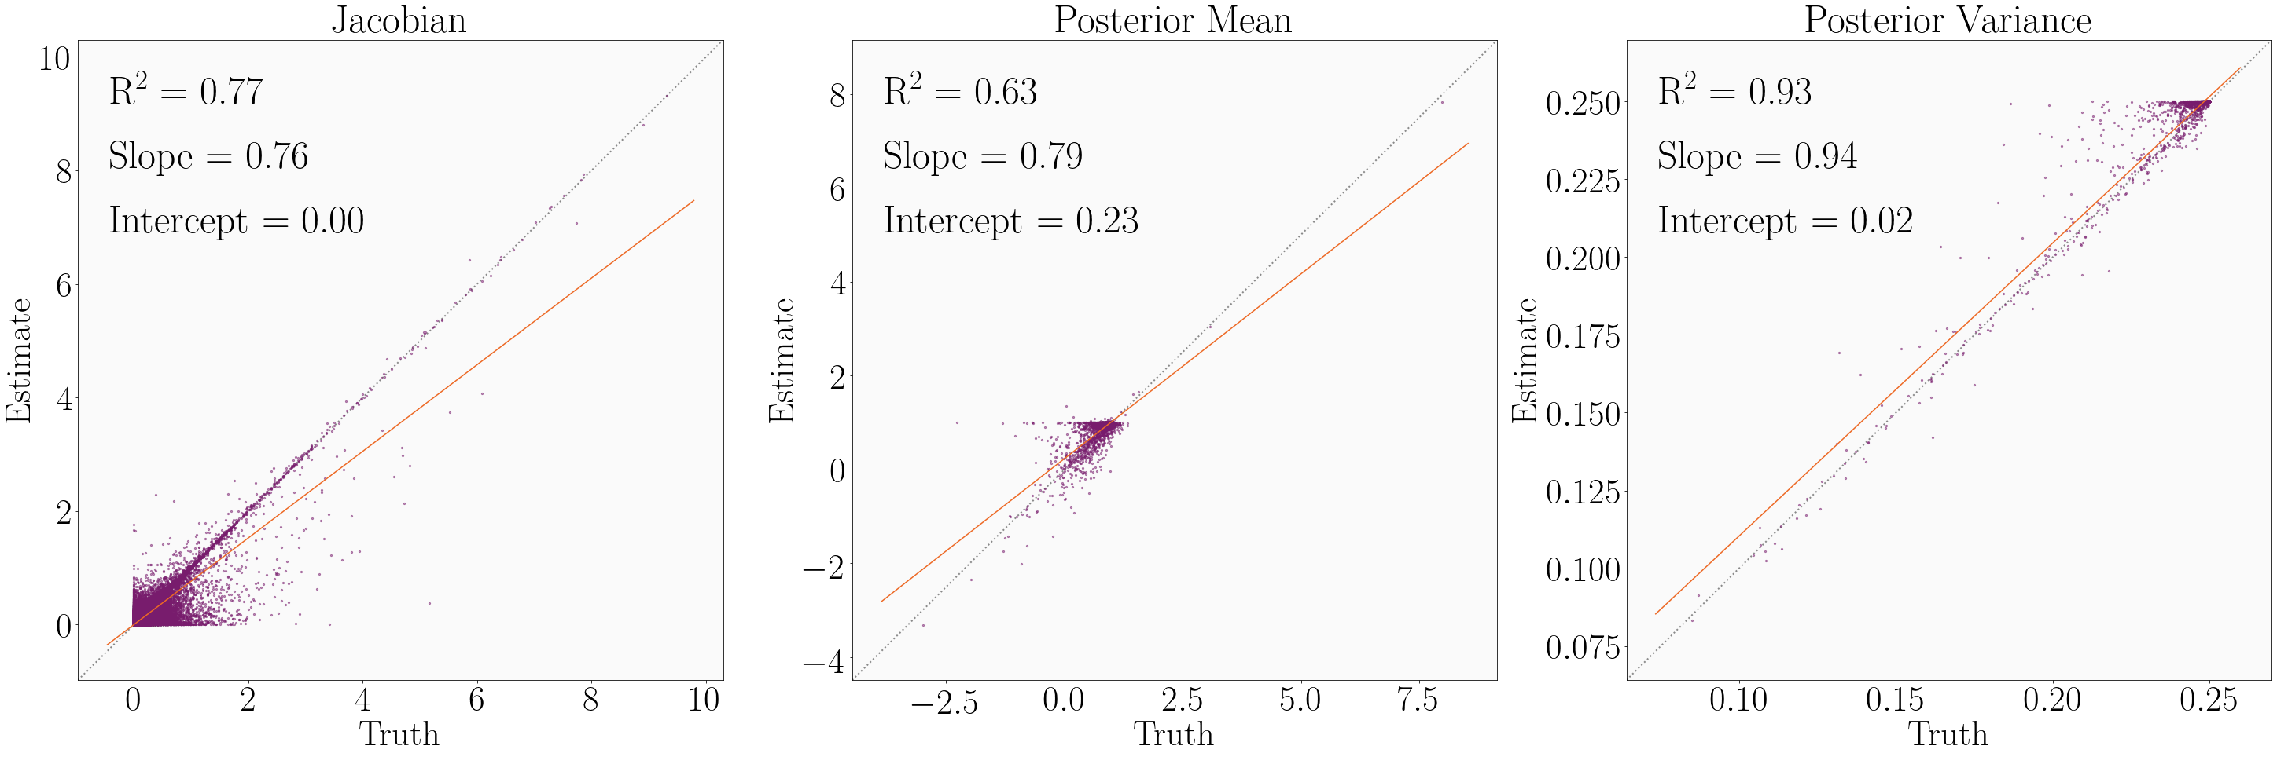

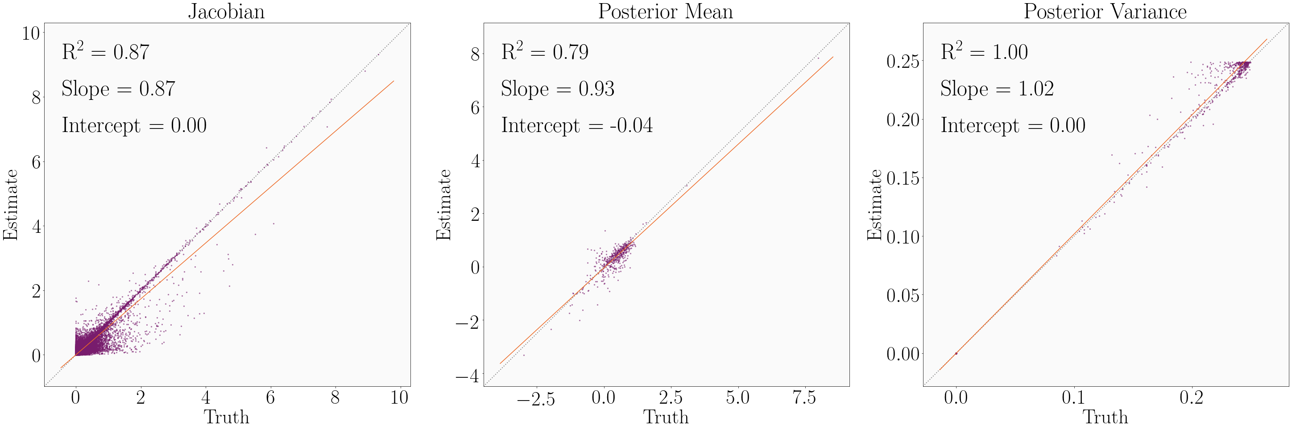

Figure 8: The second update low-rank Jacobian and the corresponding posterior mean and variance plotted element-wise against the true Jacobian, posterior mean, and posterior variance, from left to right. The first row shows all elements. The second row applies a filter that excludes grid boxes with averaging kernel matrix diagonal values less than 0.005, improving the fit in all cases but reducing the number of optimized grid cells from 2,098 to 465.

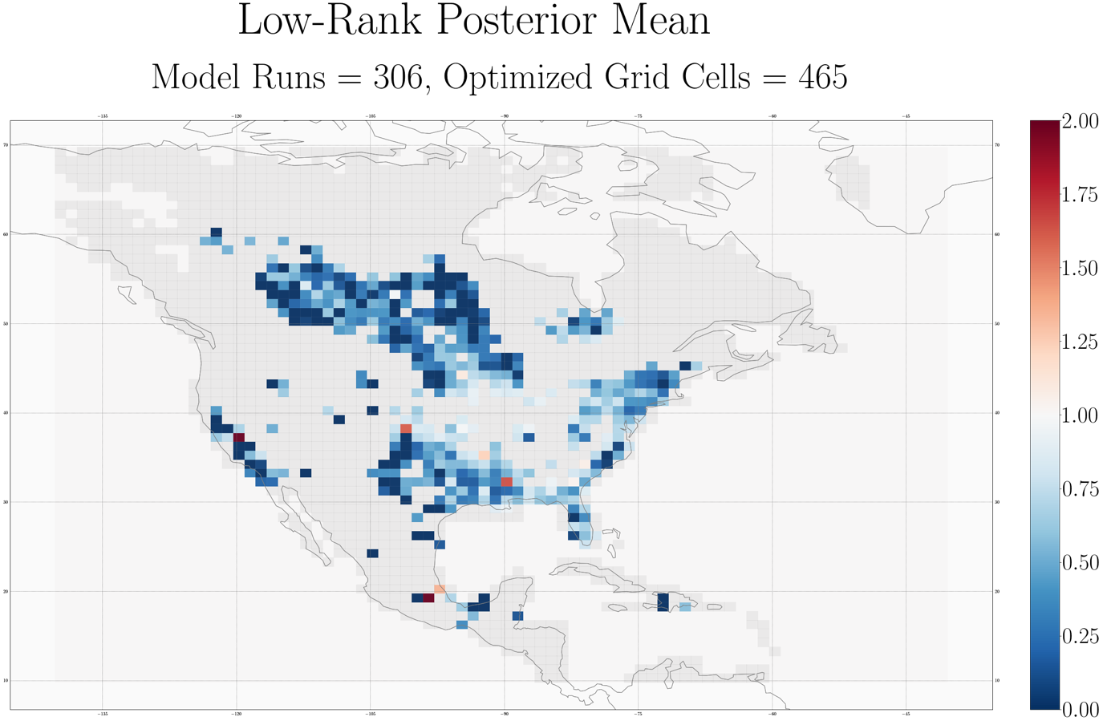

[Note: missing difference plot here.]

Figure 9: The posterior mean associated with the low-rank Jacobian (left) and the difference between the approximate posterior mean and true posterior mean (right).

The errors in the filtered approximate posterior mean are mostly insignificant. Figure 10 shows in purple the distribution of the absolute error in the approximate posterior mean, as measured against the true posterior mean, and in orange the distribution of the posterior error, as given by the posterior error variance. Most of the errors in the approximate posterior mean are significantly smaller than the posterior error. There are some errors that are larger than the posterior errors; it is worth noting that (1) following the inverse framework of Maasakers et al. (2019), prior errors are capped at 0.5, resulting in a similar cap on posterior errors [in the furture: check the math here] and (2) posterior errors calculated in an analytic inversion often underestimate the true posterior errors (insert citation). It is therefore likely that even in the limited cases when the error in the approximate mean is larger than the calculated posterior error, the error in the mean is likely negligible.



[Note: I need to change a lot on this plot. The left axis corresponds to the purple histogram, which shows the histogram of error in the approximate posterior mean as measured against the true posterior mean. The right axis corresponds to the orange histogram, which shows the histogram of error as given by the posterior error variance. The x-axis shows the error values.]

Figure 10: Distribution of errors in the approximate posterior mean as given by the difference between the approximate and true means (purple) and the posterior variance (orange). Most of the error in the approximate mean is less than the error given by the posterior variance.

We also conduct an inversion with a Jacobian constructed using the Gaussian mixture model (GMM) approach described by Turner and Jacob (2015) following Maasakkers et al. (update once published). [Insert description of GMM and GMM results here.]

**Section 4: Conclusions**

We suggest two methods of decreasing the computational cost of analytic Bayesian inversions of linear systems by an order of magnitude. We reduce the number of model numbers necessary to characterize the linear relationship between modeled observations and emissions, given by the Jacobian matrix. In the standard approach, constructing the Jacobian requires a model run for each state vector element, here taken to be a grid cell, optimized. We demonstrate two methods that reduce the number of model runs by an order of magnitude. Both methods take advantage of the spatial variability in information content in the inverse system by constraining at either highest resolution or highest accuracy those grid cells that are most informed. The methods iteratively update a low-cost initial estimate of the Jacobian built using a mass balance approach on the prior emissions estimate. The first method constructs a reduced-dimension Jacobian by iteratively developing a multiscale grid that preserves resolution where information content is highest. The second method constructs a low-rank Jacobian by perturbing the dominant patters of information content. We demonstrate both methods in an inversion of GOSAT atmospheric methane column observations over the North American domain for July 2009 at 1º x 1.25º resolution. We also construct a reduced-dimension Jacobian following the Gaussian mixture model (GMM) approach described by Turner and Jacob (2015). In all cases, we reduce the number of model runs from 2,098 to ~300.

The reduced-dimension, low-rank, and GMM Jacobians all reduce the number of model runs necessary to construct a Jacobian, and therefore the computational cost of an analytic inversion, by an order of magnitude. The three Jacobians produce posterior means and variances that approximate the true posterior mean and variance to varying degrees. The reduced-dimension Jacobian produces everywhere on the multi-scale grid an exact, but lacks accuracy when regridded to the original resolution. The low-rank Jacobian produces an approximate solution at the original resolution. However, it is most accurate in the subset of grid cells with highest information content. Still, it constrains more grid cells per model run than a Jacobian constructed using a full finite-difference scheme. It also makes explicit that the inversion is solved only where there is sufficient information content. [Insert GMM Jacobian conclusion.] Both of our approaches introduce additional error by reducing the number of model runs. However, most of these errors are smaller than the posterior errors and it is likely that the errors are smaller than the true posterior errors. Increasing the number of model runs will decrease these errors.

While the proposed methods are evaluated in the context of an inversion of atmospheric methane column observations, they are applicable in any linear system, including many long-lived climate forcers. As satellite observations of atmospheric constituents continue to improve, it will be possible to conduct inversions at increasingly high resolution. While analytic inversions provide characterization of the information content and can help avoid over-interpretation of inverse results, their computational cost is limited by the number of grid cells constrained by the inversion. Our approaches allow analytic solution of the inverse system at significantly reduced computational cost. Future work could consider the expansion of both approaches to the temporal dimension. And, as cloud computing becomes increasingly available, the computational benefits of performing large, parallel computations in cloud environments should be considered.

[Note: I kept the conclusion short, anticipating significant changes to the rest of the text that will change the tone/content of the conclusion.]

**References**

[Insert references]